 

**Placement Empowerment Program**  
**Cloud Computing and DevOps Centre**

## **Host a Static Website Locally: Set Up a Local Apache Server and Host an HTML Page**

**Name:** Jeslin Anista J  
**Department:** EEE



## **Introduction and Overview**

This POC demonstrates how to host a static website locally using the Apache HTTP Server. By following these steps, you will gain hands-on experience in configuring and running a local web server, a foundational skill for web hosting and server management.

## **Objective**

1. Set up a local Apache web server.
2. Configure the server to host static files.
3. Create and host a simple HTML page displaying your name.

## **Importance of Local Hosting**

* **Hands-On Learning:** Gain practical experience in server setup.
* **Testing Ground:** Debug websites before deploying them live.
* **Offline Development:** Work on projects without an internet connection.

## **Step-by-Step Instructions**

### ****Step 1: Download Apache****

* Search for **"Apache Lounge"** on Google.
* Click the first link to access the official website.

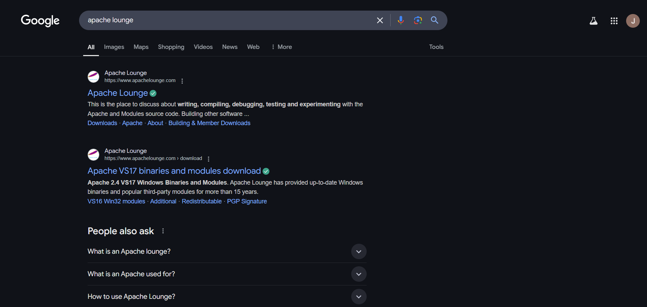

### ****Step 2: Get the Apache Package****

* Click on **"Downloads"** on the left-hand side.
* Download **"Apache 2.4.62-240904 Win64"** (Windows version).

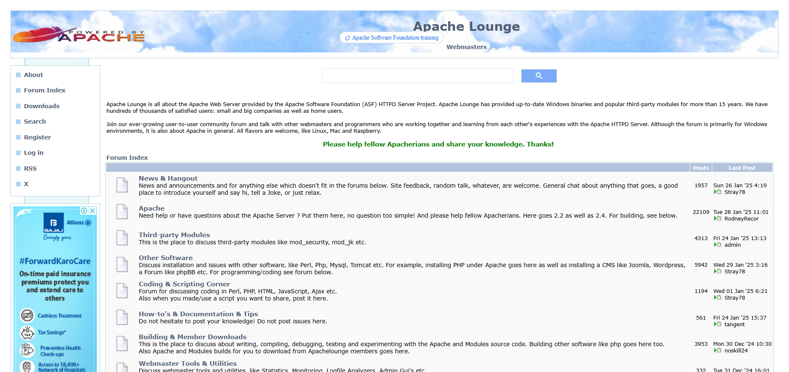

* Extract all files from the downloaded package.

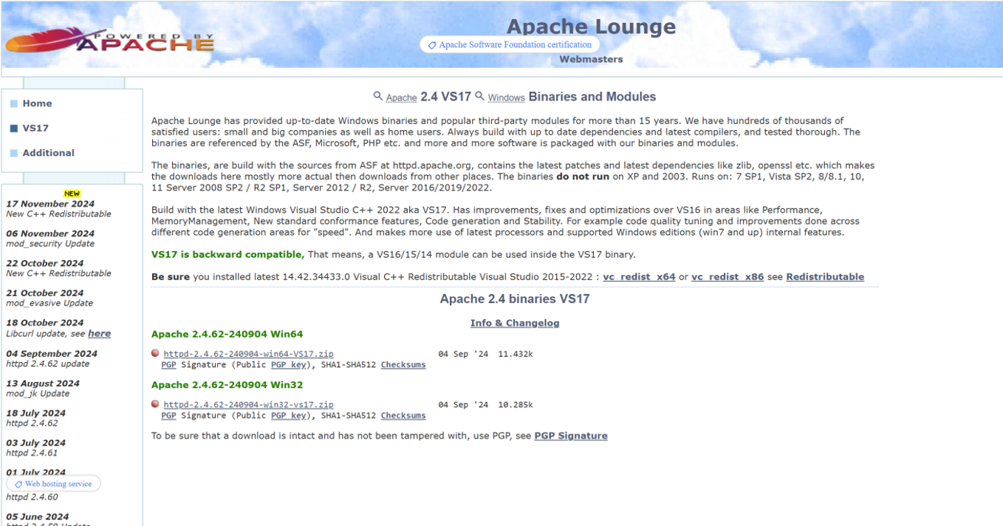

### ****Step 3: Open Command Prompt****

* Open **Command Prompt as Administrator** (Win + R, type cmd, right-click → "Run as Administrator").Screenshot 2025-01-22 155734.png
* Navigate to the Apache bin folder using:
* cd C:\path\to\apache\bin

### ****Step 4: Install Apache****

* Run the installation command:
* httpd.exe -k install

### ****Step 5: Configure Apache****

* Navigate to the **Apache conf folder**.
* Open httpd.conf in Notepad (Apache/conf/httpd.conf). 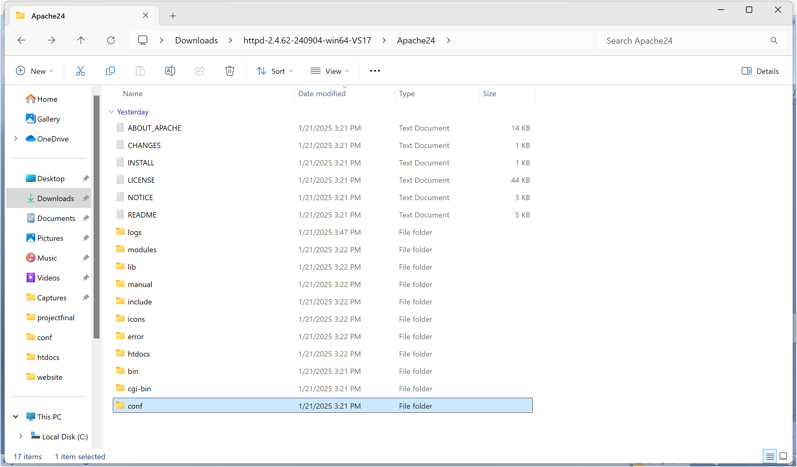

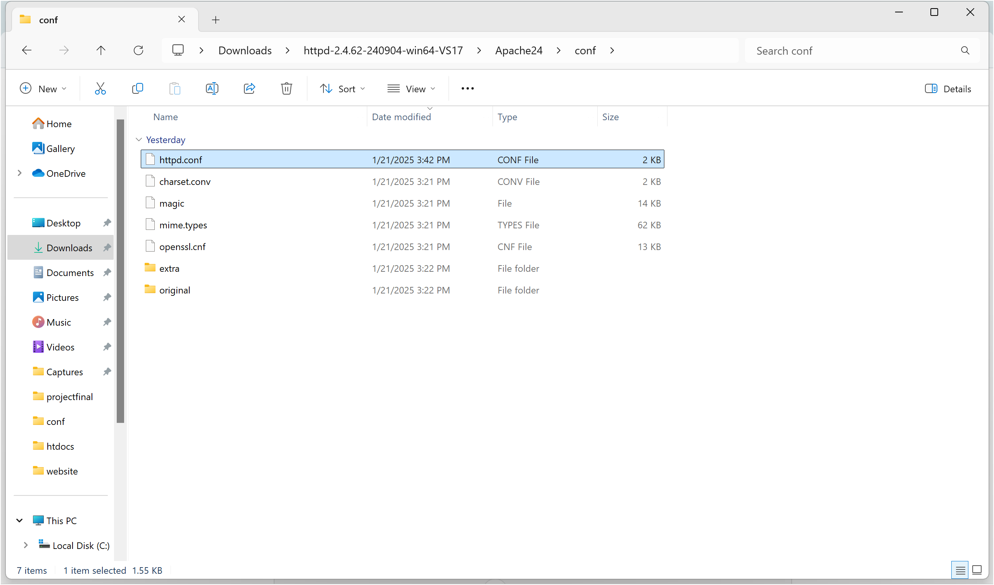Modify configurations, ensuring the SRVROOT directive matches your Apache installation path. 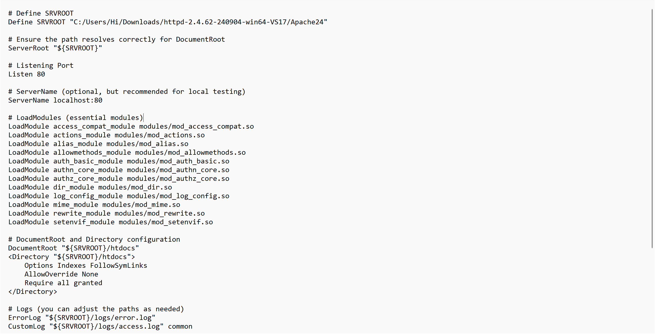

### Screenshot 2025-01-22 172408.png

### ****Step 6: Test Configuration****

* Run the following command to check for errors: httpd.exe -t
* If successful, it should display: **"Syntax OK"**.

### ****Step 7: Start Apache Server****

* Start the server using:
* httpd.exe -k start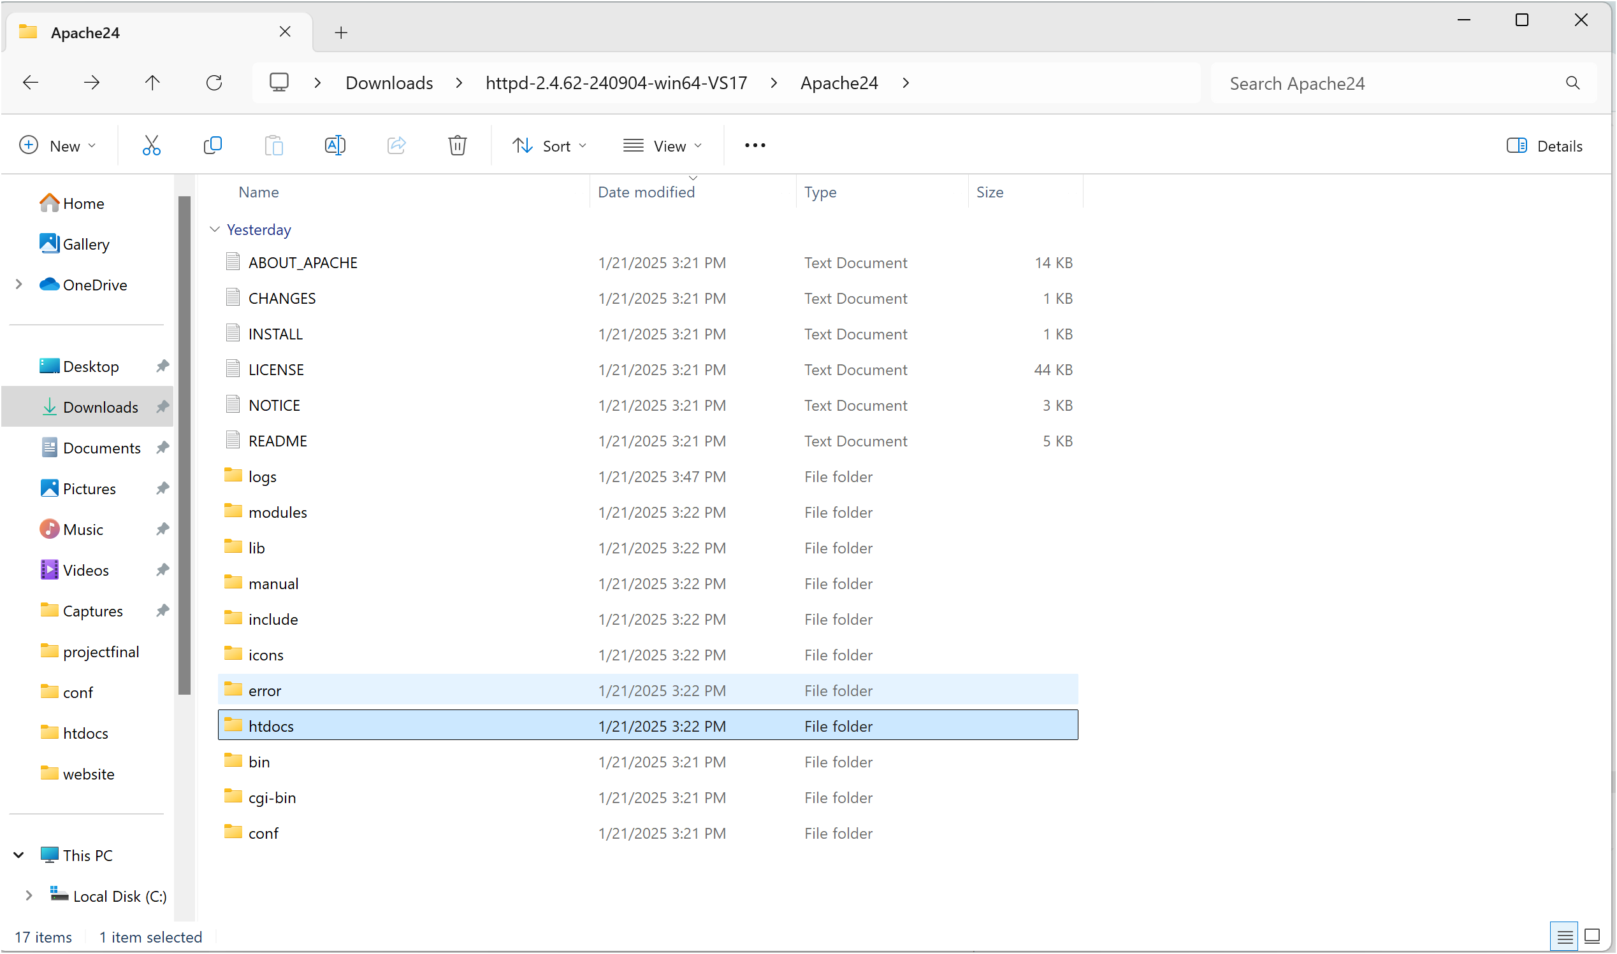

### ****Step 8: Modify HTML File****

### Navigate to the htdocs folder inside Apache. Screenshot 2025-01-22 174342.pngScreenshot 2025-01-22 174907.png

* Open index.html and edit it to display your name.

### ****Step 9: View the Hosted Website****

* Open **Chrome** or any browser.
* Type localhost/index.html in the address bar.
* 
* Your website should be visible!

## **Expected Outcome**

1. Successfully configure and run an Apache server.
2. Host a static HTML website displaying your name.
3. Understand basic web server setup and file hosting.